***BASIC COURSE:***

The system displays the Account Details Page to the User. The User clicks on the Degrees Text Box and adds or removes degrees. The User clicks on the Interests Text Box and adds or removes interests. The User clicks the Save Changes Button, and the system displays the “Changes Saved” Message. The system updates the User Degree List and User Interest List in the Database. The system queries the AI Service to update the User Recommendations List with possible matches based on the User’s degrees and interests changes.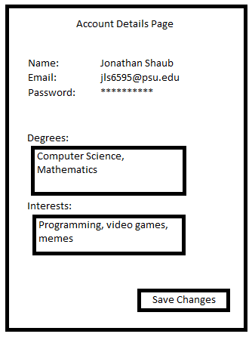

***ALTERNATE COURSES:***

**The User is not logged in:** The system redirects the User to the Login Page.

**Number of characters in the Degrees Text Box > 1,000**: The User clicks the Save Changes Button and the system displays the “Character Limit Exceeded in Degrees” Error Message. The system does not save the changes to the Database.

**Number of characters in the Interests Text Box > 10,000**: The User clicks the Save Changes Button and the system displays the “Character Limit Exceeded in Interests” Error Message. The system does not save the changes to the Database.

**The User navigates away from the Account Details Page without clicking the Save Changes Button**: The system does not save changes in the Degrees Text Box and the Interests Text Box to the Database.